National Research Nuclear University "MEPhI"

Department of particle physics and cosmology (№40)

Small thesis on the topic:

"MirRor world without weak interaction"

Done: student of group М18-115
Alena Mufazalova
Taken: prof, M. Yu. Khlopov

Moscow, 2019
Introduction
Before 1956 it was assumed that mirror reflection of the process with any fundamental particle leads to the same process or other process which also does exist in nature. Discovery of parity violation in weak interaction initiated the study [of] the processes in which this fundamental rule is violated (for instance neutrinos in β- decay have only one polarization).
A P-transformation of coordinate system which describes the P-violating process corresponds to transition from left to right coordinate system or mirror reflection of processes. On the one hand, such transformation leads to a process that does not exist in nature. On the other hand, the existence of a preferred coordinate system means that the empty space-time itself has a preferred orientation.
To restore the equivalence of left and right Lee and Yang [1] supposed that all the known particles must have their mirror twins. In this case the P-inversion must be accompanied by change of ordinary particles by their mirror partners.
The simplest solution was to put antiparticle for the role of mirror particle. But due to discovery of CP-violation it was assumed in the paper [2] that ordinary particles have mirror partners which [do] not coincide with antiparticles.
The easiest way to include mirror particles in model of particles [style] is to add to [the] $SU\left(2\right)⊗U\left(1\right)⊗{SU\left(3\right)}_{C}$ – gauge symmetry of standard model the same symmetry but corresponding to mirror particles.
Evolution of the Universe and his[???] cosmological consequence of mirror world without weak interaction are presented in this work.
There is considered the model of mirror world with ${SU}_{M}\left(3\right)⊗U_{M}\left(1\right)$ symmetries and only first family of fermions: $\left(\begin{matrix}u \\ d\end{matrix}\right)$ quarks which have the same masses as the ordinary u- and d-quarks and $\left(\begin{matrix}e \\ ν_{e}\end{matrix}\right)$ leptons which have also the same masses. [there are neutrino oscillations and SM electron neutrino doesn’t have definite value of mass] The electric charges of particles are opposite [in what sense? You cannot observe mirror electric charge, but kinetic photon-mirror photon mixing can in principle probe this sign as a ‘millicharge’] in sign.
In electroweak model, masses of quarks and leptons are generated as result of interaction with Higgs field. This, in turn, is caused by a local CP violation of the symmetry of SU(2)⊗U(1). [??? Please, clarify] However, in addition to a weak CP violation, there is a strong CP violation.
In R. Peccei and H. Quinn model [3] is considered the additional symmetry $U_{PQ}\left(1\right)$. This symmetry is spontaneously broken by some complex scalar field $ϕ$on some energy scale. My assumption is this field in mirror world may be the Higgs field which may give the mass to mirror particles. [This is an additional assumption, so that your mirror symmetry is SU(2)⊗U(1) ⊗U(1)_{PQ}. Moreover, you want to generate same masses for mirror quarks and leptons. Please, check that the corresponding Yukawa couplings do not spoil your U(1)_{PQ} ]
Cosmological consequences
Let[‘s] adopt the mirror world model with SU(3)⊗U(1) symmetry with the first generation of fermions. Now we are able to create mirror matter resistant to β - decay. In this case, the neutrons will become stable particles. The mesons $π^{±}$and protons will remain stable particles because they decay only by weak interaction. Electrons are born in decays only by weak interaction, therefore, they also remain stable.[They are stable owing conservation of electromagnetic charge!!!]
Let consider the complete model including mirror particles without weak interaction. First of all, the mirror world has the same kinds of interactions excluding the weak but they apply only to mirror particles. However, indeed, we would have a doubling of some hadron states having a general strong interaction as well as a doubling of atomic states having a general electromagnetic interaction due to additional degrees of freedom. Thus, we have mirror electromagnetic and mirror strong interactions.
A possible way to interact with our world, the particles of the mirror world is to interact with gravity.[style] Therefore, the mirror and ordinary gravitational interactions will be the same. In addition, kinetic mixing of ordinary and mirror particles is possible.
In the framework of Grand unified gauge symmetry
$$[SU\left(2\right)⊗U\left(1\right)⊗{SU\left(3\right)}_{C}]_{O}⊗[U\left(1\right)⊗{SU\left(3\right)}_{C}]_{M}$$
of ordinary and mirror particles [style] is included in a single symmetry group $G_{OM}$. The violation of this group leads to the separation of the ordinary and the mirror sector of particles under condition to strict discrete symmetry between [you evidently don’t have strict symmetry in your model] them.
Let us assume that in the mirror Universe there is an asymmetry of charges as in our world.
Inflation
To realization the inflation process, it is required to introduce an additional scalar inflation field into the model which can interacting with particles of matter of the ordinary and mirror world and must decay so that in the post-inflationary period effectively generate the observed number of baryons and leptons of our world and suppress the number of mirror baryons and leptons.
In our case, the model of chaotic inflation is applicable (Linde, 1983) [4] where the amplitude of the inflaton field can be different for the ordinary and mirror world.[This is an additional assumption – inflaton was not assumed in your model]
The initial amplitudes of ordinary and mirror inflatons can be different which leads to the formation of a domain structure in the distribution of ordinary and mirror matter under the framework of the chaotic inflation model [5]. In areas where the amplitude of ordinary inflatons is higher after inflation ordinary particles should dominate and the admixture of mirror particles should be exponentially small. Conversely, the dominance of mirror inflatons leads to a low density of ordinary particles after inflation.[6]
Baryosynthesis
It is assumed that the baryon excess has been formed in the process of baryosynthesis (Sakharov, 1967; Kuzmin, 1970) [7-8] leading to the baryon asymmetry of the initially baryon-symmetric Universe. Baryon excess in this case occurs due to CP - disturbing effects at the exit from the balance of processes with non-preservation of the baryon number.
However, in the mirror world, this effect of CP violation is not present without a weak interaction which is why the asymmetry of mirror matter and mirror antimatter on the mechanism of electroweak interaction is impossible. But if we assume that in the mirror world, as in ours, at high energies there is a union of strong and electromagnetic interaction, then the vertices in Fig.1 are possible:
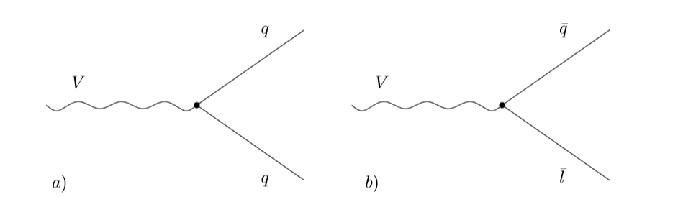
Figure 1 The interaction of the vector boson with the quarks, antiquarks and antileptons [9]
both in our world and in the mirror world. In this case, there is a violation of the baryon number in the process (Fig. 2): [This is also an additional assumption]
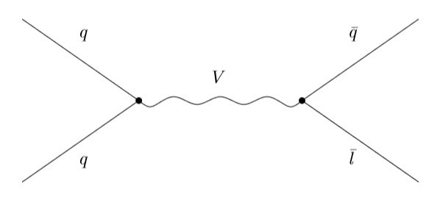
Figure 2 – The process with the exchange of a vector boson, leading to a violation of the baryon number [9].
By introducing new supermassive mirror particles vectors and scalars involved in mirror interactions with ordinary mirror particles, the decay of such particles would lead to asymmetry of mirror and ordinary baryons through the interactions presented in Fig. 1.
Thus, the only way to get the asymmetry of mirror matter and antimatter is the introduction of new massive particles the decay of which will lead to baryon excess. At the same time, the lifetime of such particles should be less than 1 sec in order for them to completely disintegrate to the stage of nucleosynthesis.
Dark matter candidates
The main properties dark matter particles must have are:
- Electroneutrality
- Stability (lifetime [>>] 14·10⁹ years)
- Nonzero mass
Under these conditions, some mirror particles in the absence of weak interaction can be particles of dark matter. But only in condition the mass of the mirror substance is much larger than the mass of ordinary particles. This is possible if there was a freezing out of mirror particles.
In particular, mirror baryons can be candidates for the role of dark matter, they can form compact objects with stellar masses and sizes. [6]

Evolution
Let us consider how the further evolution of the model of the Universe with the mirror world took place without weak interaction.
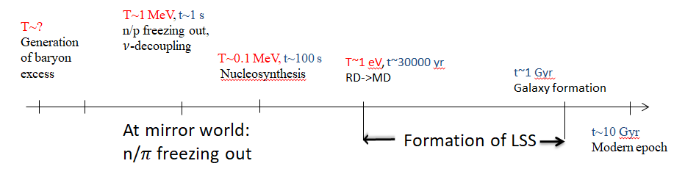
Figure 3 – Thermal evolution of the Universe
Following the inflation phase of the Universe evolution stage is the reheating. It was during this stage an active birth of high-energy particles and their thermalization. [10]
The birth of particles in the mirror world occurs during this period, as in the case of particles of the ordinary world, due to rapid oscillations of the inflaton field near the minimum potential.
Let us consider the process of freezing out stable particles of the model. In this case, neutrons, protons, charged pions and electrons (positrons) remain stable.
Let’s calculate the number density of nonrelativistic particle by formula [11]:
$$n={\left(\frac{2}{π^{3}}\right)}^{1/2}\frac{m^{3/2}{\left(kT\right)}^{3/2}}{ℏ^{3}}exp\left(-\frac{mc^{2}}{kT}\right),$$
Let's estimate the freezing out temperature from the following considerations.
The freeze out moment is expressed from equation of the Universe expantion law $ρ≈\frac{1}{Gt_{1}^{2 }}$and the mass density expression$ρ≈\frac{kT_{1}}{c^{2}}{\left(\frac{kT_{1}}{cℏ}\right)}^{3}$. At the freeze out moment [time] $kТ≤mc^{2}$ then approximately $kТ=\frac{mc^{2}}{α}$, where $α≳1.$
$$t_{1}=α^{2}G^{-1/2}m^{-2}ℏ^{3/2}c^{-3/2}$$
And the temperature of freeze out estimated from the approximate expression:
$$T_{freez out}≈0,86 MeV\sqrt{\frac{1 sec}{t_{1}}}$$
Then get:
 | $$t_{1}, sec$$ | $T_{freez out}$, MeV | $$n_{freez out}, {sm}^{-3}$$
$$π^{±}$$ | $$4,236⋅{10}^{-4}$$ | 41,785 | 1,135$∙{10}^{61}$
$$n^{0}$$ | $$8,536⋅{10}^{-9}$$ | 9308,319 | 1,667$⋅{10}^{67}$
$$e^{±}$$ | 31.584 | 0.153 | 5.74$∙{10}^{44}$

For a proton, due to the almost equality of masses, we get the same values as for the neutron. [If you have mirror baryon asymmetry these estimations are not valid]
So the freeze out of the neutron to proton ratio in the mirror world occurs by the following reactions:
$$π^{+}n→π^{0}p$$
$$π^{-}p→π^{0}n$$
At the first second there is a freezing out of relativistic neutrinos in our world. This process is due to the fact that the neutrino is out of balance, since the inverse lifetime of the neutrino
${τ_{ν}}^{-1}=σ_{ann.}n_{υ}\sim T^{5}$ ,
And expansion rate $\sim \frac{1}{T^{2}}$ . However, in a mirror world without weak interaction, a neutrino cannot be born in $e^{-}e^{+}$ reactions, as well as scattering on electrons and annihilate since such processes go through a weak interaction. Hence, we obtain that mirror neutrinos are not initially present in the equilibrium state, so the decoupling of mirror neutrinos does not occur.
There are a birth of relic mirror neutrinos and their further “cooling” as the Universe expands. In the mirror world, the birth of neutrinos occurs only in a gravitational way. In view of what their concentration will be extremely small and the mass should be of the order of ~kT (1 sec) since in the mirror world there is only the first generation of leptons, the oscillations between different varieties of mirror neutrinos does not exist, but we can assume that the oscillations occur between our world and the mirror with one generation. In this case, the mirror electron neutrino may be a candidate for the role of sterile neutrino.
The density of ordinary and mirror radiation is different at the RD stage due to different equilibrium temperatures.

The observed abundance of ⁴Не is
У_{obs} = (28 ±12)%
The freezing out the number ratio of neutrons and protons in the ordinary substance after the first second of expansion the contribution of mirror photons and mirror electron-positron pairs should be taken into account in the full density. However, given the assumption that the equilibrium temperature in the mirror world was lower the contribution of mirror photons is suppressed and the contribution of electron-positron pairs is significantly less than that of other stable particles.
The temperature decreases, the massive particles become non-relativistic and the photon wavelength increases as the Universe expands. There comes a time when the rest energy of the particles is compared with their kinetic energy. [mirror baryons are nonrelativistic much earlier!] From this point on the matter dominant stage begins.
At this stage the Large Scale Structure of the Universe (LSS) is formed. The influence of mirror matter on LSS is possible only in the case of large scale mirror domains corresponding to the mass scale:
$$M>{10}^{16}M_{⊙}$$
or large scale islands distribution of baryons. In this case the mirror baryon islands have to look like voids which have not Galaxies from ordinary matter.
The most of the matter is dark matter in our world, however, in the mirror world it may not be so. If the temperature in the mirror world is less but the baryon asymmetry is greater mirror matter can play the role of dark matter in our world.
The pions are stable in the mirror world. They participate in recharge [charge exchange] reactions which generating protons and neutrons. Thus, mirror nuclei can play the role of direct latent mass, since such nuclei must remain stable.
Please analyze effect of charge exchange reactions $$π^{+}n→π^{0}p$$
$$π^{-}p→π^{0}n$$
and forms of mirror matter – nucleosynthesis in your mirror world, types of mirror objects that can be formed.
Conclusion
Thus, in the model of the mirror world without weak interaction with the first generation of fermions, most of the baryons, charged pions and leptons remain stable. And also the process of annihilation of neutrinos by weak interaction is impossible, which is why their number becomes small.
Mirror baryons can be candidates for the role of the dark matter. [what kinds of mirror nuclei are formed? Pay special attention to pion atoms – negative charged pion is bound with nuclei much earlier, than recombination with mirror electrons takes place] Mirror neutrinos are not initially present in the equilibrium state, so the decoupling of mirror neutrinos does not occur.
The mirror world model does not affect the amount of primary helium concentration.
The influence of mirror matter on the Large Scale Structure of the Universe is possible in the case of large-scale mirror domains or Large Scale Island distribution of baryons.
References
- Lee T.D., Yang C.N., 1956. Phys. Rev. 104, 245.
- Kobzarev I.Yu., Okun L.B., Pomeranchuk I.Ya., 1966. Nuclear Physics [Sov.J.Nucl.Phys.], 3, 1154.
- Emelyanov V.M., Belotsky K.M. :Lectures of electroweak model and new physics.
- Linde A. D. 1983. Phys. Lett. 129B, 177.
- Dubrovich V. K., Khlopov M.Yu., 1989. Astron. Jornal, 66, 248
- Blinnikov S.M.: Mirror matter and other models for dark matter. Advances in physical Sciences: Volume 184, No. 2, p.-? 2014.
- Sakharov A.D., Violation of CP-invariance, C-asymmetry and baryon asymmetry of the universe, 1967, Letters of Journal of experimental and theoretical physics. [JETP Lett.] 5, 32
- Kuzmin V. A., 1970, Letters to of experimental and theoretical physics. 12, 335.
- Gorbunov D.S., Rubakov V.A., Introduction to the theory of the early universe. Theory of the hot Universe, 2006
- Khlopov M. Yu.: Basics of cosmomicrophysics. USSR, 2004
- Zeldovich Y.B., Novikov I.D., Structure and evolution of the Universe. 1975
- Bronnikov K.A., Rubin S.G., Lectures on gravitation and cosmology, 2008
Please add more references to original works

