MINISTRY OF EDUCATION AND SCIENCE OF THE RUSSIAN FEDERATION
Federal State Autonomous Educational Institution of Higher Professional Education
National Research Nuclear University "MEPhI"
Institute of Nuclear Physics and Technology (INPT)

DEPARTMENT №40

«Elementary particle physics»

ABSTRACT:

Dark matter

Fulfilled: Nikiforov A.G.
Group: M18-115
Received: prof. Khlopov M.Yu.

Moscow 2019
Contents

Annotation 3
1. Evidences of dark matter 4
2. Dark matter candidates 6
2.1.Weakly interacting massive particles (WIMPs) 6
2.2. Alternatives to natural WIMPs 7
2.2.1. Axions 7
2.2.2. Sterile Neutrinos 7
2.2.3. Composite dark matter from fourth generation 8
ГЛАВА 3. 10
Заключение 14
Список использованных источников 15

Annotation

Our universe is made up of more than just visible matter. In fact, visible matter accounts for as little as four percent of the total density of the universe. Twenty-three percent of our universe consists of the so-called dark matter, a type of matter that has so far only appeared through its gravitational effect and has not yet been detected. The dark matter is needed to describe various observable effects that could not be explained without their existence. The remaining 73% of our universe consists of a much less understood form of energy, the dark energy. It has not yet been proven, but its existence is considered assured. The knowledge of the composition of our universe we owe to various experiments and measurements. Thus, from the fact of a flat universe, which fact can be confirmed by measurements of the background radiation (see lecture on CMB), a connection can be deduced between the density of the dark energy and the total matter. Neglecting the radiation density ρ_{s}, and after introducing a density Ω normalized to the critical density ρ_{c}, the following relationship arises

$$Ω_{λ}+Ω_{m}=1. (1)$$

Here $Ω_{λ}$ stands for the normalized density of the dark energy and $Ω_{m}$ for the normalized density of the entire matter, including the total sum of the dark matter and the known matter.
Another relationship between these two parameters can be established,

$$Ω_{λ}=c+b∙Ω_{m } (2)$$

where the constants c and b can be determined from observations of the supernova explosions. By the two relations just mentioned one can conclude clearly on $Ω_{λ}$ and $Ω_{m}$. Finally, only the density of known matter needs to be determined to know the actual composition of the universe. This density can be determined from the power spectrum of the cosmic background radiation. Thus, the ratio of the height of the first peak to the height of the second peak gives a direct indication of the density of known matter $Ω_{b}$. If one summarizes all the results of the different measurements, the result is the familiar diagram describing the composition of our universe.

- Evidences of dark matter

The existence of dark matter can be explained by three essential points. Thus, with the help of gravitational lenses, rotational velocities of stars in spiral galaxies and the structure of the universe one can infer the existence of matter, in addition to known matter. For example, the stars on the edge of spiral galaxies move at speeds far greater than they are likely to be due to visible matter and Kepler laws. If one assumes only a matter distribution, which corresponds to the visible one, would expect a drop of the rotation speed with $\frac{1}{\sqrt{R}}$ for large distances. Where R stands for the distance from the center of the galaxy. In fact, however, this drop could not be observed (see Fig. 1.). Thus, one can assume that more than just the visible mass must exist.
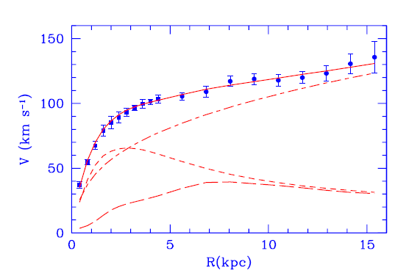
Figure 1. M33 rotation curve (points) compared with the best fit model (continuous line). Also shown the halo contribution (dasheddotted line), the stellar disk (short dashed line) and the gas contribution (long dashed line) [1].
Another evidence for DM existence and another method of measuring matter distribution in galaxies and clusters comes from gravitational lensing. For studying gravitational lensing in the beginning the most luminous clusters were selected. However, in modern times there are many clusters detected solely by lensing effects. Recent observations of Bullet cluster reveal separation of visible matter, ICM and dark matter halo, which were individually located using X-ray observations and lensing technique. This is why Bullet cluster is often cited as one of the best astrophysical evidences for dark matter models.
Theoretically, effect of gravitational deflection of light, was firstly pointed out at the end of 18th century, independently by British, Henry Cavendish, and German, Johann G. von Soldner, physicists. They suggested that the light ray should bend when passing close to massive celestial objects. With introduction of General relativity, Einstein recalculated the deflection angle in simple example of point-like objects. The correct value was shown to be two times larger than the one previously calculated in Newtonian mechanics:

$$α=\frac{4GM}{bc^{2}}. (3)$$

Here, α is the angle of deflection, M is the mass of gravitational lens, and b is the impact parameter of the bended light ray (fig. 2) [2].

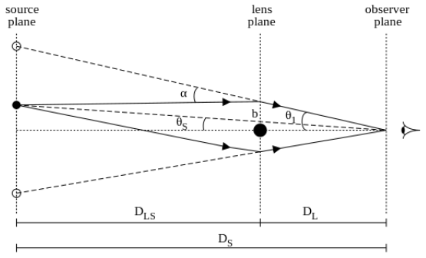
Figure. 2. Scheme of gravitational lensing[2]
2. Dark matter candidates
2.1. Weakly interacting massive particles (WIMPs)

The class of dark matter candidates that has attracted the most attention over the past four decades is weakly interacting massive particles (WIMPs). WIMPs appeared for a long time as a perfect dark matter candidate, as new particles at the weak scale would naturally be produced with the right relic abundance in the early universe [3], while at the same time they might alleviate the infamous hierarchy problem [4], that has been a main driver of particle physics for roughly four decades [5]. Despite much effort, no particle other than a Standard Model-like Higgs boson has been convincingly detected at the weak scale so far, a circumstance that, as long anticipated [6], now raises the possibility that natural WIMPs may have been nothing more than an attractive red herring [7].
The prototypical natural theory is the minimal supersymmetric (SUSY) standard model, which introduces an additional partner for each Standard Model particle. In addition, the partners of the electroweak bosons are predicted to be WIMPs, and thus are natural dark matter candidates. However, most of the parameter space of natural simple supersymmetric models is essentially ruled out. Although it is still possible to identify ‘natural’ realizations of SUSY, e.g. in regions of parameter space of the phenomenological Minimal Supersymmetric Model, it is undeniable that null searches are constraining larger and larger portions of the parameter space of supersymmetric theories, which begs the question of how much fine-tuning one is willing to accept before giving up the hope to discover SUSY [7].

2.2. Alternatives to natural WIMPs
2.2.1. Axions
Another very popular class of dark matter candidates is that of axions and axion-like candidates. Axions are light ultra-weakly coupled particles which arise as a byproduct in theories which solve the ‘strong-CP problem.’ The symmetries of the Standard Model of particle physics would allow for the strong nuclear force to include an electric dipole moment (edm) for the neutron, which would represent an asymmetry in the charge distributions of the quarks which make it up. However, measurements indicate that the neutron edm is about 10⁻¹⁰ times smaller than naively expected, begging for a dynamical explanation. The dynamics which would cancel the neutron edm also produce a new particle: the axion.
Many constraints exist on axions and axion-like models. A class of searches typified by the ADMX experiment uses a magnetic field to convert the background of axions on the Earth into an electromagnetic signal, and has successfully excluded a window of axion parameter space with masses around 2 µeV, and future data taking is expected to probe masses up to about 40 µeV. In addition, there is vigorous theoretical activity exploring new ideas to probe a wider range of axion masses [7].

2.2.2. Sterile Neutrinos

Another well-motivated candidate is a sterile neutrino which experiences a diluted form of the weak nuclear force through mixing with the “ordinary” active neutrinos. Such particles are a typical ingredient in theories which explain the fact that neutrinos have been experimentally found to be massive, in contrast to the predictions of the Standard Model. While their residual weak interactions predict that they will ultimately decay, if their mass and mixing are both small enough, the decay may occur slowly enough that they remain in the Universe today as a form of dark matter. They can be produced in the early Universe through a variety of different physical mechanisms with an appropriate abundance.
While the lifetime of a sterile neutrino playing the role of dark matter must be long enough that the vast majority of such particles have not yet decayed, quantum mechanics dictates that some will decay more rapidly, leading to a source of mono-energetic photons with energy close to half of its mass. In fact, an unidentified emission line at 3.5 keV in the stacked X-ray spectrum of 73 galaxy clusters has prompted the suggestion that it might be a hint of the decay of a sterile neutrino, though debate about the origin of this line is still ongoing. Future X-ray telescopes such as eRosita, XARM, Athena, and/or Lynx should help to clarify the origin of this emission, and future accelerator searches such as SHIP will provide a complementary probe of the relevant parameter space [7].

2.2.3. Composite dark matter from fourth generation (дальше проработать)

Hypothesis of heavy stable quark of fourth family can provide a nontrivial solution for cosmological dark matter if baryon asymmetry in fourth family has negative sign and the excess of $\overline{U}$ antiquarks with charge (-2/3) is generated in early Universe. Excessive $\overline{U}$ antiquarks form ($\overline{U}\overline{U}\overline{U}$) antibaryons with electric charge -2, which are all captured by ⁴He and trapped in [${{}_{ }^{4}{He}}^{++}{(\overline{U}\overline{U}\overline{U})}^{--}$] O-helium OHe "atom", as soon as ⁴He is formed in Big Bang Nucleosynthesis. Interaction of O-helium with nuclei opens new path to creation heavy nuclides in Big Bang nucleosynthesis. Due to large mass of U quark, OHe "atomic" gas decouples from baryonic matter and plays the role of dark matter in large scale structure formation with structures in small scales being suppressed. Owing to nuclear interaction with matter cosmic O-helium from galactic dark matter halo are slowed down in Earth below the thresholds of underground dark matter detectors. However, experimental test of this hypothesis is possible in search for OHe in balloon-borne experiments and for U hadrons in cosmic rays and accelerators. OHe "atoms" might form anomalous isotopes and can cause cold nuclear transformations in matter, offering possible way to exclude their existence.

Список литературы

- Corbelli E., Salucci P. The extended rotation curve and the dark matter halo of M33 //Monthly Notices of the Royal Astronomical Society. – 2000. – Т. 311. – №. 2. – С. 441-447.
- Luković V., Cabella P., Vittorio N. Dark matter in cosmology //International Journal of Modern Physics A. – 2014. – Т. 29. – №. 19. – С. 1443001.
- Bertone, G., Hooper, D. & Silk, J. Particle dark matter: Evidence, candidates and constraints. Phys. Rept. 405, 279–390 (2005). DOI 10.1016/j.physrep.2004.08.031.
- de Gouvea, A., Hernandez, D. & Tait, T. M. P. Criteria for Natural Hierarchies. Phys. Rev. D89, 115005 (2014). DOI 10.1103/PhysRevD.89.115005.
- Dine, M. Naturalness Under Stress. Ann. Rev. Nucl. Part. Sci. 65, 43–62 (2015). DOI 10.1146/annurevnucl-102014-022053.
- Bertone, G. The moment of truth for WIMP Dark Matter. Nat. 468, 389–393 (2010). DOI 10.1038/nature09509
- Bertone G., Tait T. M. P. A new era in the search for dark matter //Nature. – 2018. – Т. 562. – №. 7725. – С. 51.

